**Technion**

*Electrical Engineering Department*

High Speed Digital System Lab

Image Manipulation Core for FPGA

**Version**:

**Last update**:

**Written By**: Ran Mizrahi , Uri Tsipin

Table of Contents

1 Introduction 3

1.1 Abstract 3

1.2 Applications 3

1.2.1 Pilot Helmets 3

1.2.2 Intelligence Surveillance Devices 3

1.2.3 Surgical Applications 4

1.2.4 Printer 4

2 Goals 4

3 Project requirements 5

4 The algorithm 5

4.1 Crop Input Image 5

4.2 Image Rotation 5

4.2.1 Calculation of source pixel address 6

4.2.2 Bilinear Interpolation 7

4.3 Zoom 8

4.3.1 Mathematical background 8

4.3.2 Implementation 8

4.4 User defined output resolution 9

Table of Figures

Figure 1 3

Figure 2 3

Figure 3 4

Figure 4 4

Figure 5 – Example Of Image Cropping 5

Figure 6 - Example of 30 degree rotation 6

Figure 7 - A counterclockwise rotation of a vector through angle θ 6

Figure 8 7

Figure 9 8

Figure 10 8

Figure 11 8

# Introduction

## Abstract

Many modern digital devices excute different image manipulations. These manipulations requires image rotation and zooming.

Image Processing algorithms are "heavy consumers" of resources and therefor we would to boost the procces using hardware acceleration.

## Applications

### Pilot Helmets

Modern Day Pilot Helmets contains a digital display module. Due to the helmets geometry, being elliptic and not straight, there's a need to "deform" the displayed image.  
Part of the "deformation" algorithm requires to rotate the image and zooming in/out of the image.  
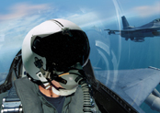

Figure 1

### Intelligence Surveillance Devices

Security forces use different surveillance devices, and sometimes due to terrain conditions there is a need to rotate the image in order to make make the surveillance more comfortable.  
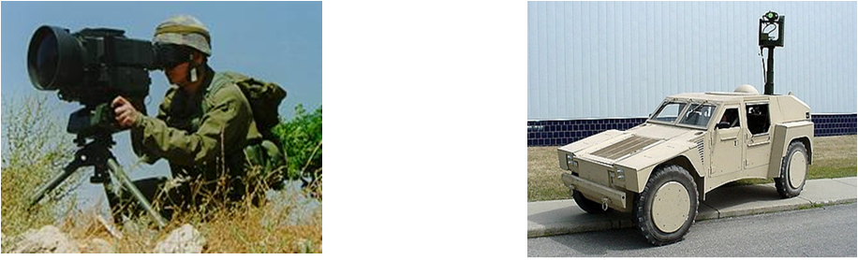

Figure 2

### Surgical Applications

Tiny cameras and Optical fibers are commonly used in various medical procedures. In order to improve the image and ease the procedure image rotation and zooming is necessary.

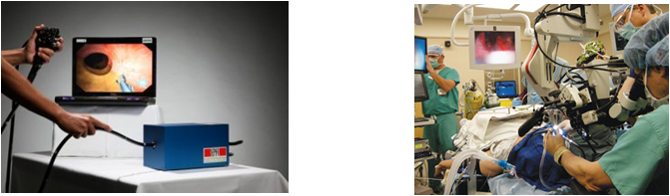

Figure 3

### Printer

New age printers have a built-in LCD display, using our feature the user will have the ability to edit (crop, zoom, rotate) the image before it is sent out to print simply and fast  
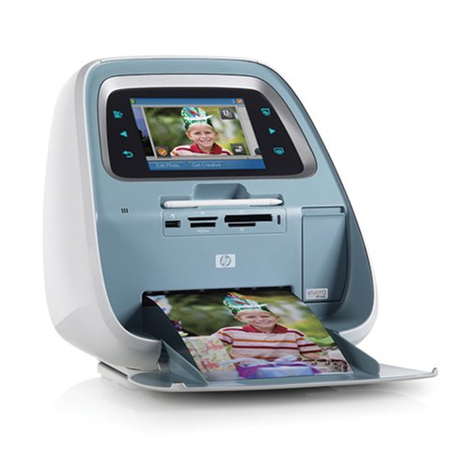

Figure 4

# Goals

Implement a FPGA core using VHDL. The core will execute the following objectives

* Full panoramic rotation: 0 to 360 degrees.
* Support of Zoom function.
* Support of crop image by user defined coordinates.

Building a GUI (Graphical User Interface) using Matlab. The GUI will transfer data packets (including the image, required zoom/rotation parameters/crop coordinates) to the FPGA.  
Finally, the GUI will display the output image for Debug purposes.

# Project requirements

* Input Image resolution must be 600x800 and monochromatic.
* Output image resolution will be 480x640.
* Zoom factor must be greater than 1 (which means zoom in only).

# The algorithm

להוסיף רקע הסבר על מה זה תמונה במחשב (מטריצה) וכדו'  
  
----

The Algorithm executes four operations, where "Crop Input Image"(4.1) is carried out separately before the other function which work simultaneously

## Crop Input Image

The user inputs (x_start,y_start) coordinates which describe the top left corner of the required cropped image, where (1,1) leaves the original picture intact.

The algorithm defines a new image which copies the original image matrix starting from  
(x_start,y_start) coordinates until the end of the matrix size.  
In case of colored picture, the matrix is three dimensional, the third dimension will be copied according to the same coordinates.

Figure 5 – Example Of Image Cropping

## Image Rotation

The rotation algorithm includes three main stages

* define a black picture with the required input dimensions
* Scanning the output image, pixel by pixel, and calculating the source coordinate of the pixel in original image.

Figure 6 - Example of 30 degree rotation

* Evaluating the grey/color level of the pixel using bi-linear interpolation.

### Calculation of source pixel address

Assume the pixel coordinate in the orginal image matrix is   
For a rotation over an angle ,  in the original image is mapped onto the point in the output image.

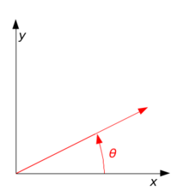

Figure 7 - A counterclockwise rotation of a vector through angle θ

The relation between the points is:



During the algorithm we scan the output image and we evaluate the grey level of the original non-rotated image and therefore we need to use the inverse transform:



Since a matrix cell address is a positive integer we have a problem calculating the source address using this method because cosine and sine functions give real values. Hence we will round up and down the values and evaluate the grey level using bilinear interpolation.

### Bilinear Interpolation

Once we round up the address values a problem rises, we cannot restore the original pixel address in the source image, and therefore we evaluate the grey/color level using bilinear interpolation.  
Bilinear Interpolation performs a weighted average between the four sourrounding neighbours of the required "real" address according to the following method:

* R1, R2 are the weighted averages between the top pair and the bottom pair , accordingly.
* Output is the weighted average between R1 and R2

Figure 8

The following formula describes the bilinear interpolation (weighted average):



## Zoom

### Mathematical background

The zoom function is achieved by using the mathematical operation of scaling the axis. For example- in one dimension: 

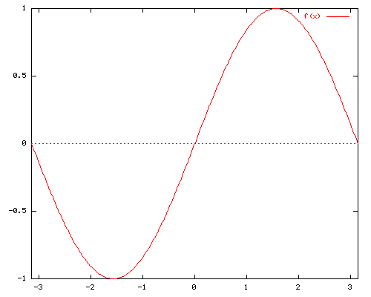

Figure 9

By scaling the X axis with the factor 'a', we receive the follow result:



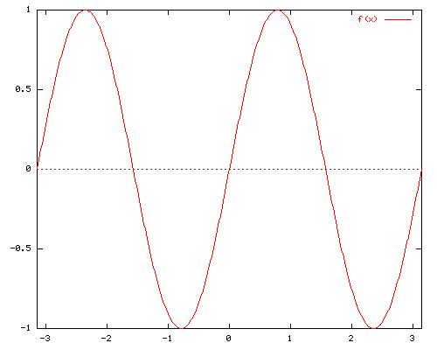

Figure 10



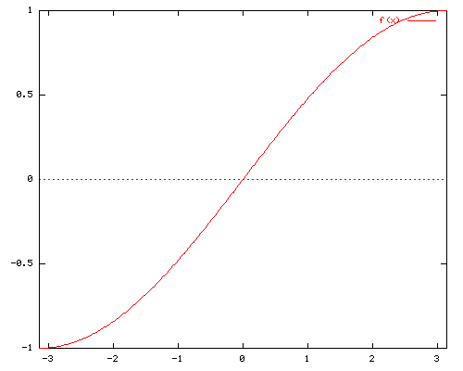

Figure 11

We induct the same principle in two dimensions- (x,y) axis.

### Implementation

In order to zoom in during the scan of the source image, the algorithm multiplies the number of appearances of a source pixel in the output image, according to the zoom factor.

In order to zoom out, in the output image we "skip" every specific amount of pixels in the source image- according the zoom factor. The following formula describes both actions:



## User defined output resolution

The algorithm assumes that the output resolution is smaller or equal to the source resolution. In case the output resolution is smaller, the algorithm shrinks the source image in order to fit it in the new frame. The implementation is identical to the zoom function, only with different factors. The following formula describes the action:



And the same for Y axis.